H.P.E.D.

Human Powered Energy Drive

Product Design:-
In the above design, the components have been considered and assembled in an optimum way to achieve optimal conservation of human power into useful work. The sewing machine base with the help of foot-pedal is used to input human energy through mechanical work which is then transferred to a pulley system which in-turn directs this mechanical energy to the flexible transmission shaft as rotary motion. This motion is then transferred to a Dive Divide which would turn the power supplied into multiple ports to be used by the user for different means. Through these ports the consumer can plug in different appliances and power them accordingly. At present, a portable fan has been designed which would run both on electricity and human power.

Product Fabrication:-

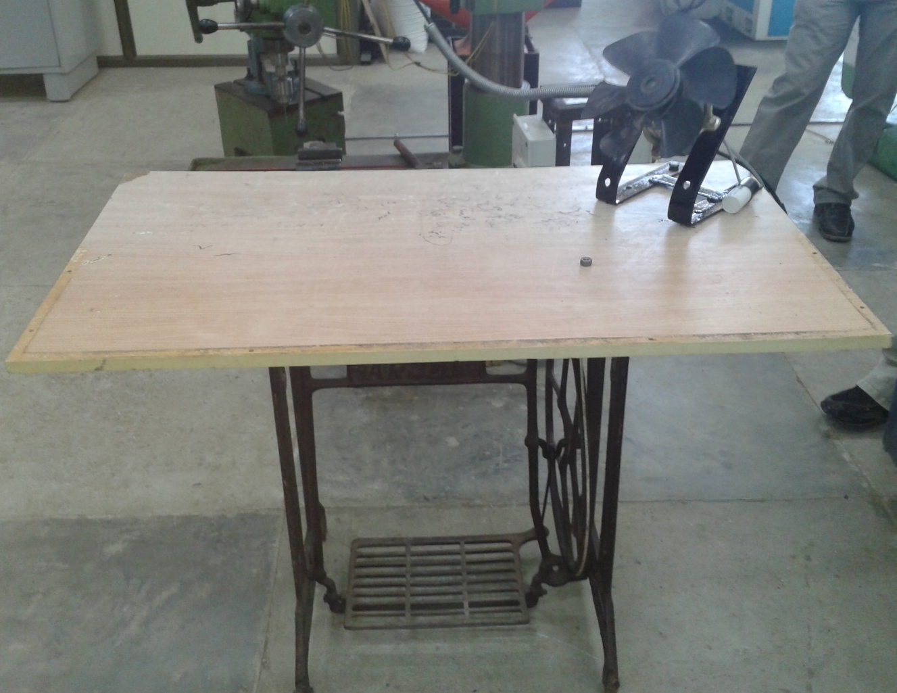

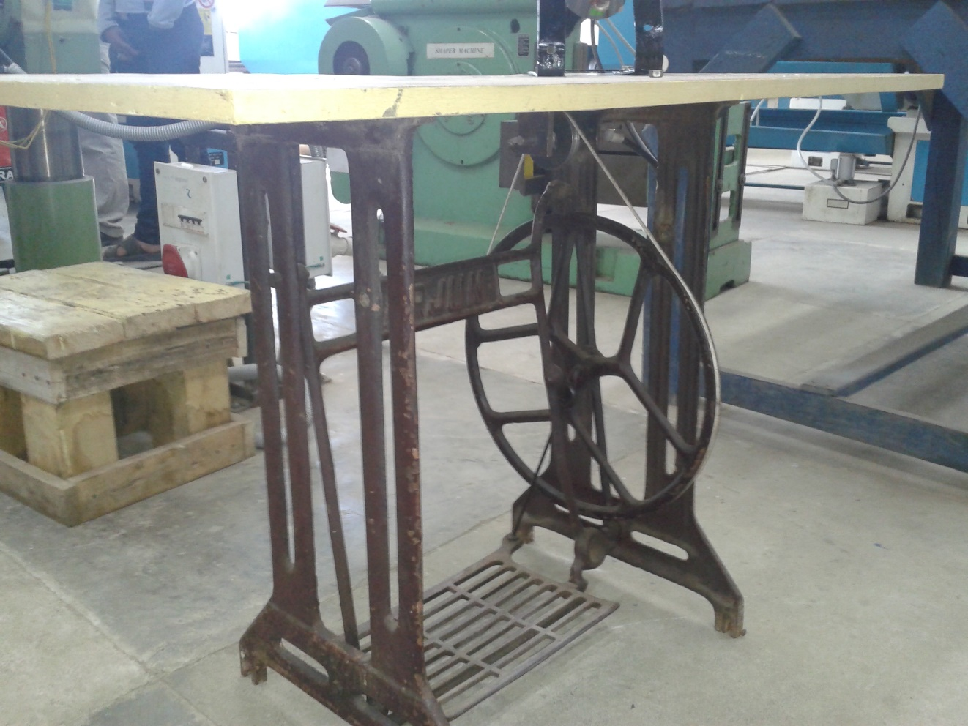
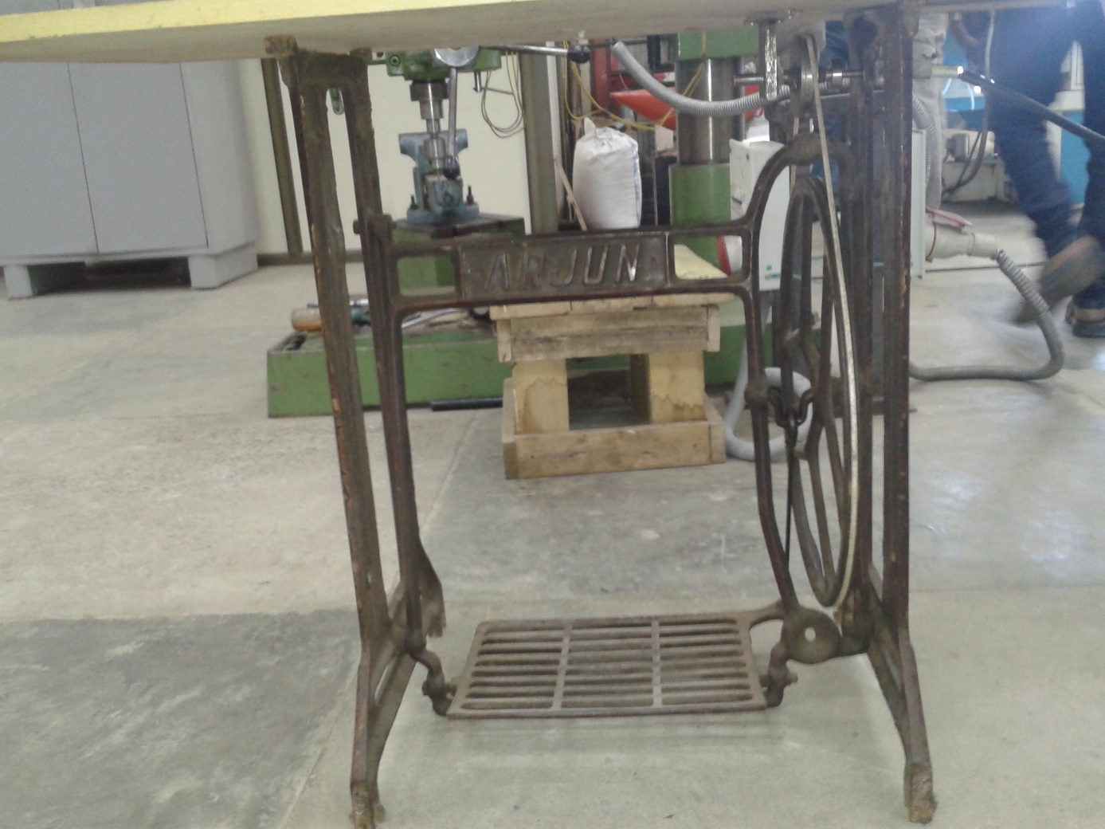

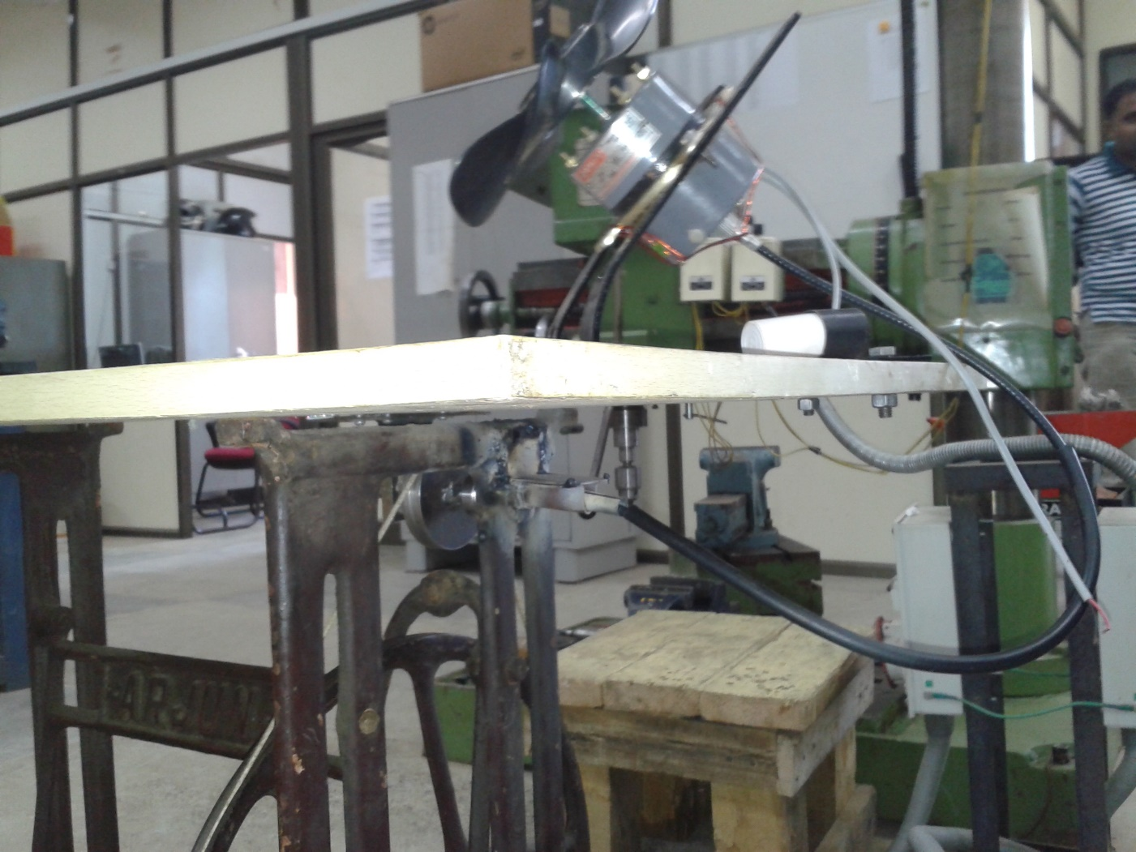

Mold Generation:-
Footplate Die Design
Frame Die Design
Mid-frame Die Design

